Final Project of Forecasting Analytics
Yan Li @ 04242015
Chapter 9 Problem 1
The problem is using three weeks bus (15mins interval) passenger data to forecast the future bus usage. It requires high accuracy since the bus company needs to adjust the bus schedule and buy more busses.
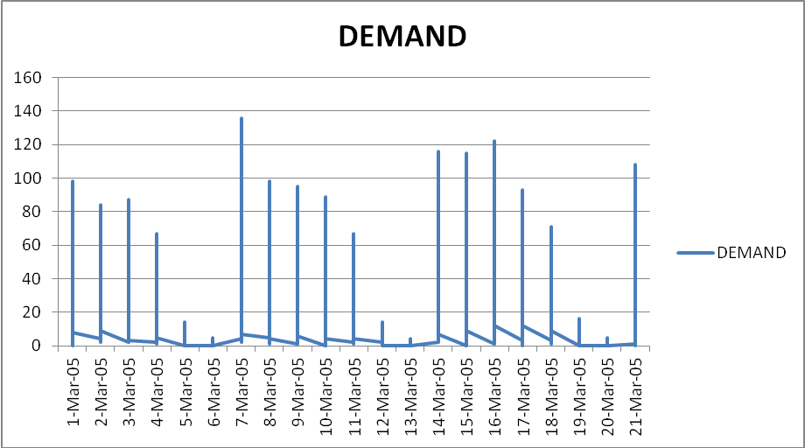
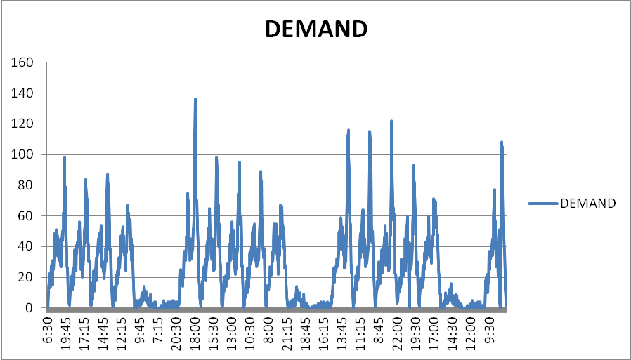
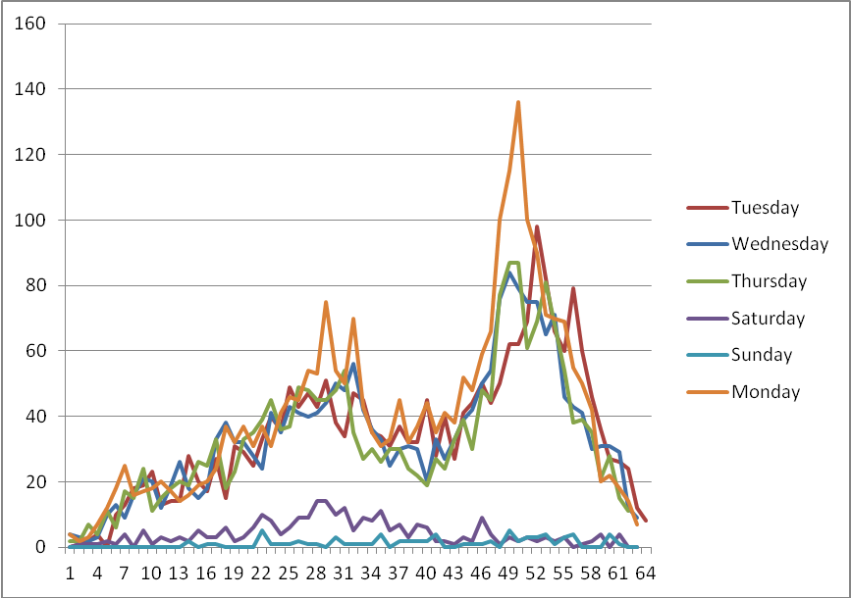
First from the three week time series plot by date, by time interval, we can see:
1 There is hardly any trend; so the model does not need to take care of trend;
2 There is a weekly pattern, which is the first seasonality of the data;
3 There is a cyclic pattern with one day, which will be the second seasonality of the data;
4 The weekday series all have similar patterns but weekend series are different.
5 All the above features are global.
Thus we can use two different forecasting models to fit weekdays and weekend separately. Weekday series can be modeled by Holt-Winters to capture the two seasonality; the weekend series can be fitted by regression or simply exponential smoothing method.

